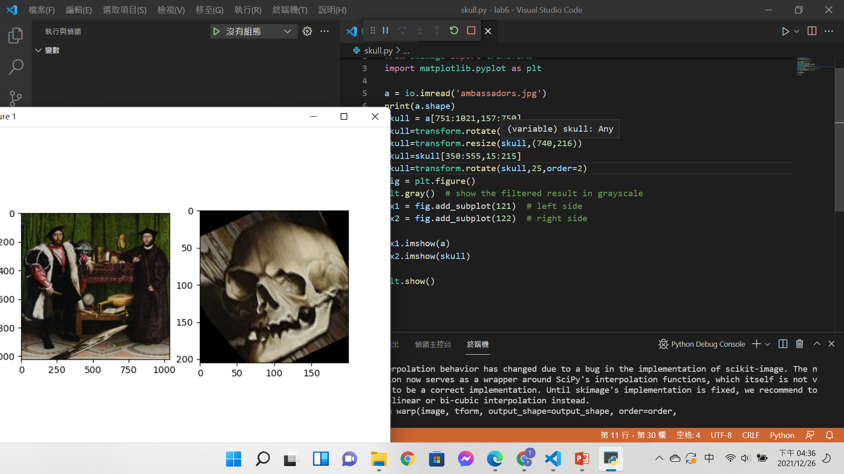

Code:

from skimage import io

from skimage import transform

import matplotlib.pyplot as plt

a = io.imread('ambassadors.jpg')

print(a.shape)

skull = a[751:1021,157:750]

skull=transform.rotate(skull,-25,order=2)

skull=transform.resize(skull,(740,216))

skull=skull[350:555,15:215]

skull=transform.rotate(skull,25,order=2)

fig = plt.figure()

plt.gray()  # show the filtered result in grayscale

ax1 = fig.add_subplot(121)  # left side

ax2 = fig.add_subplot(122)  # right side

ax1.imshow(a)

ax2.imshow(skull)

plt.show()

心得:

雖然因為有點看不懂修正影像失真數學式子的部分，但是透過resize將他往y方向拉長，x方向擠壓還是成功的將骷摟頭擷取下來了。